Sermon – Pursuing Lifestyle Generosity – (36.5 minutes allowed)
(Part of the Series: Follow: Journey with Jesus in Mark’s Gospel)

INTRODUCTION (5.0 minutes):

- Greeting & Background:
  - Thirty-four years ago, on this very day, I married Teresa Marie Kelleher in the backyard of her childhood home on 22 Orchard Street in the Hillside of Medford, MA.
    - 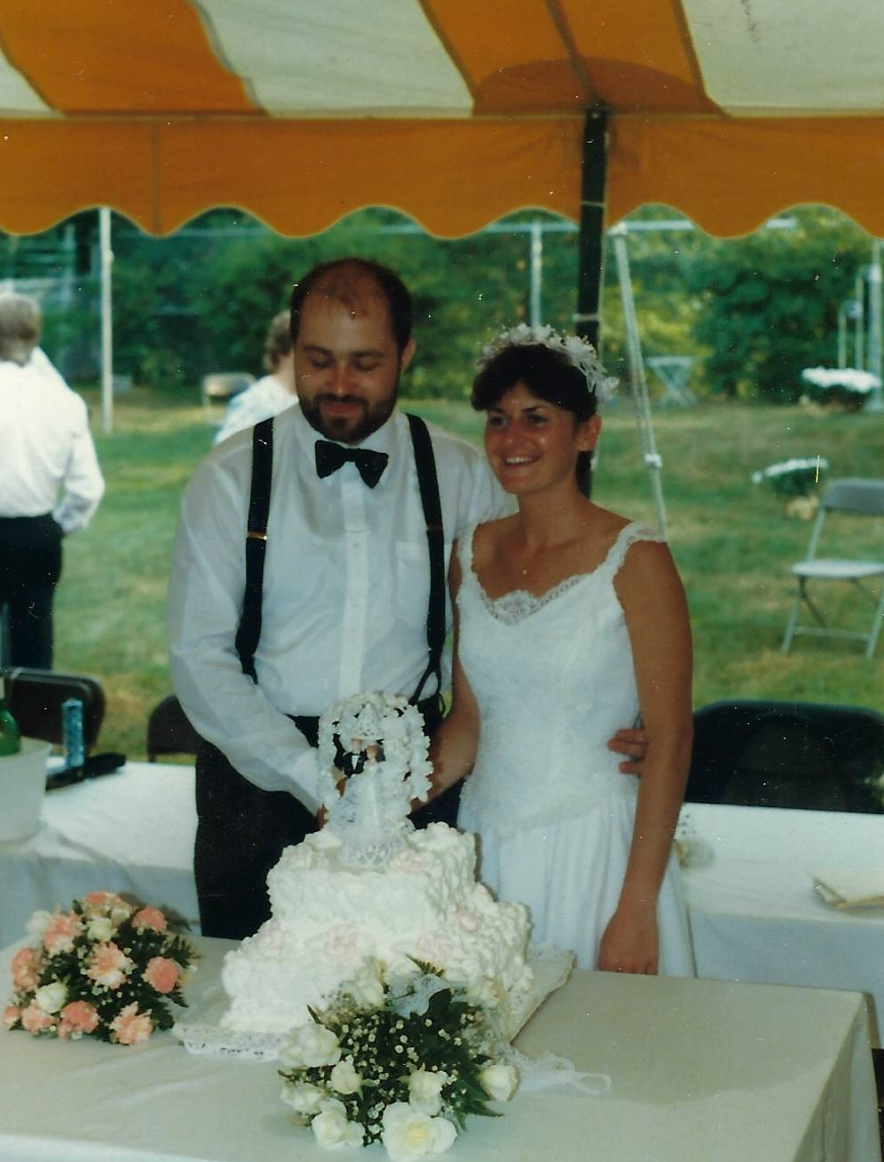 (photo displayed)
      - Happy Anniversary #34, “Angelface”!
      - She was beautiful on that day…
      - I guess that I didn’t clean up too bad either…

  - As you can imagine, there was an awful lot about marriage that Teresa and I did not know about maintaining a “One-Flesh” marriage. Truth is, at that point in time, we did not understand the gospel and operated with a rather vague idea of who “God was”.

  - However, looking back, from the beginning we did wrestle together with some pretty important questions as we co-mingled our income, possessions, and wealth together.
    - How much wealth will satisfy us? How much was enough?
    - What values did we share? And, in what ways did our perspective on money differ?
    - How much should or could we earn? How hard would we pursue that end?
    - Should we budget? And, if we do…
      - What will we buy? What will be our spending priorities?
      - What will we share with others? If anything?

  - Perhaps, you are wrestling with some of those same questions today:

  - Thankfully, we both can see how God in His ever-present mercy called us into relationship with Him and slowly began to change our beliefs, attitudes, and behaviors as we surrendered to the Spirit of God shaping us as followers of Christ.

  - From all of the many questions that we had when we were first married, one key question has emerged as we have read God’s Word and listened to His Voice:
    - Would we freely pursue a heart of lifestyle generosity? [Main Point]

  - This question forms my Main Point this morning. It is one that I want to pose to you.

- Scripture Reading:
  - And so, if you will open your Bibles and turn on your Smart Phones to today’s text from the Gospel of Mark, Chapter 10.
  - Here, we will see Jesus’ familiar encounter with “the rich young ruler” – and as we consider this story… it is my prayer that this Word of the Lord challenges each one of us as it penetrates our hearts in faith and then our will in action.
  - We’ll read beginning at verse 13. [Pause]

- Let the Children Come to Me:
  - ¹³ And they were bringing children to him that he might touch them, and the disciples rebuked them. ¹⁴ But when Jesus saw it, he was indignant and said to them, “Let the children come to me; do not hinder them, for to such belongs the kingdom of God. ¹⁵ Truly, I say to you, whoever does not receive the kingdom of God like a child shall not enter it.” ¹⁶ And he took them in his arms and blessed them, laying his hands on them.

- The Rich Young Man:
  - ¹⁷ And as he was setting out on his journey, a man ran up and knelt before him and asked him, “Good Teacher, what must I do to inherit eternal life?” ¹⁸ And Jesus said to him, “Why do you call me good? No one is good except God alone. ¹⁹ You know the commandments: ‘Do not murder, Do not commit adultery, Do not steal, Do not bear false witness, Do not defraud, Honor your father and mother.’” ²⁰ And he said to him, “Teacher, all these I have kept from my youth.” ²¹ And Jesus, looking at him, loved him, and said to him, “You lack one thing: go, sell all that you have and give to the poor, and you will have treasure in heaven; and come, follow me.” ²² Disheartened by the saying, he went away sorrowful, for he had great possessions.

²³ And Jesus looked around and said to his disciples, “How difficult it will be for those who have wealth to enter the kingdom of God!” ²⁴ And the disciples were amazed at his words. But Jesus said to them again, “Children, how difficult it is^{[b]} to enter the kingdom of God! ²⁵ It is easier for a camel to go through the eye of a needle than for a rich person to enter the kingdom of God.” ²⁶ And they were exceedingly astonished, and said to him,^{[c]} “Then who can be saved?” ²⁷ Jesus looked at them and said, “With man it is impossible, but not with God. For all things are possible with God.” ²⁸ Peter began to say to him, “See, we have left everything and followed you.” ²⁹ Jesus said, “Truly, I say to you, there is no one who has left house or brothers or sisters or mother or father or children or lands, for my sake and for the gospel, ³⁰ who will not receive a hundredfold now in this time, houses and brothers and sisters and mothers and children and lands, with persecutions, and in the age to come eternal life. ³¹ But many who are first will be last, and the last first.”

MAIN BODY – Teaching – Encouragement #1: (4 minutes of 25 minutes):

- My first encouragement today is that we… “Understand the heart of Generosity”.
- In our text this morning, Mark records an episode involving children that I think will help us begin to understand what a heart that is sensitive to the kingdom of God looks like.
- Many thanks to writer Danny Akin who has helped me to consider Jesus’ encounter with children:

- Like little children, we come to Jesus helpless yet hopeful.
  - ¹⁴ But when Jesus saw it, he was indignant and said to them, “Let the children come to me; do not hinder them, for to such belongs the kingdom of God.
  - By their very nature, children’s lives are in the hands of others. They don’t know all they need, but they know instinctually that they need the help of another and are hopeful that they will receive it. They have no clout or standing. They bring nothing except empty hands.

- Like little children, we come to Jesus trusting and dependent.
  - ¹⁵ Truly, I say to you, whoever does not receive the kingdom of God like a child shall not enter it.”
  - Jesus says the kingdom of God is received, not earned. It is received like a little child, or it in not received at all. By their display of trust and absolute dependence on another, children point the way to entrance into God’s kingdom.

- Like little children, we can come to Jesus for affection and blessing.
  - ¹⁶ And he took them in his arms and blessed them, laying his hands on them.
  - Did you notice that? Jesus picked up the children. He is tender and affectionate to those who bring nothing to Him but their need. He picked up and held these children, spoke a word of blessing over them and attached a high value to their intrinsic worth. His commitment to their well-being was sure. He would not fail.

- To understand the heart of generosity, we simply begin by seeing the heart displayed in Jesus’ remarkable encounter with children.
  - When we assume the posture of being helpless yet hopeful in the goodness of God… trusting Him for all of our dependent needs… and opening ourselves to receive the words of blessing He commits Himself to fulfill on behalf of His children… then we truly in a position to receive and then to release all that He has for us. We don’t have to clench our fists in order to hold onto everything within our reach.

- My prayer for us this morning is that we see generosity as the natural outgrowth of a very intimate connection with God Himself. It is the giving away of what came from God in the first place. We come to Him with nothing but need. He calls for our trust in faith. He is our Provider. And, we then receive the privilege of becoming an extension of His benevolence.
MAIN BODY – Teaching – Encouragement #2: (7 minutes of 25 minutes):

- Which brings me to my 2nd encouragement: “Pursue a life of Generosity” as illustrated in our next story, beginning in verse 17.
  - Here we see a man… Luke calles him a “ruler”; Matthew calls him a “young man”; Mark makes it clear that he is “rich”. So, we’ll call him the “rich, young ruler”. In many sermons, he’s vilified but if we look closely, we’ll see that Jesus encounters him as sincere… his questions are fair… his posture is respectful… his answers are appear truthful…
  - He apparently believes in the future resurrection of the body and in life after death.
  - And, he seems to understand that participation in eternal life cannot be taken for granted.
  - So he asks THE critical question:
    - Verse 17 - “Good Teacher, what must I do to inherit eternal life?”

- Looking at the text, you can see the back-and-forth dialogue between Jesus and this rich, young ruler as well as between Jesus and His disciples afterwards.
- What becomes clear is this: “Following Jesus is the ONE THING that qualifies for entering the kingdom of God and obtaining salvation and eternal life”.
- Sadly, the conflict in this story is that this rich, young ruler had something else competing for the ONE THING of following Jesus.
- In the end, it was his trust in his accumulated wealth that provided his ultimate security more than “following Jesus”.
- Sadly, some of us gathered today have some other ONE THING that challenges “following Jesus”… it could be money… it could be something else… but whatever that ONE THING is, Jesus’ radical and uncompromising point-of-view is… it must be released…

- Now here’s the good news around something that sounds really hard to do…
  - When we easily go to the right person (Jesus), ask the right question (What must I do to be saved?), get the right answers from Him (Surrender ALL), AND give the right response (I surrender ALL)…
  - Life in the kingdom of God becomes “Upside Down” in amazing ways because…
    - Ultimately, you leave what really is “a little” in order to get “a lot”…
    - And, being “last” really means that you come in “first”…

- And that includes this whole idea of being a generous person!

- My prayer for us this morning is that in a materialistic culture like ours… when the vast majority of the world looks to the American church and sees incredible wealth… that our proclamations of salvation by faith in Christ alone are matched by the release of our hidden idol of “wealth”. That unlike the man in our story, our hearts made alive in Christ produce the willingness to surrender everything in our lives – including our wealth if need be – to the eternal glory of His name.
MAIN BODY – Teaching – Encouragement #3: (10 minutes of 25 minutes):
- And to that point, my final encouragement this morning will be super practical.
- As followers of Jesus, living with a posture of salvation and release, my encouragement is that each of us would “Take a Next Step in Our Generosity Journey at RHC.”

- NOW I realize that generosity can occur outside the life of the church
  - I realize that a generous heart can be demonstrated in ways other than financial but…
  - For our purposes this morning I want to focus on financial generosity at RHC as one important place of release….

- To guide us, we have developed a visual model designed to assist you in your pursuit of biblical generosity.

  - We believe that this model is a reflection of God’s heart, the gospel of Jesus Christ, and the freeing power of the Holy Spirit.

  - The “Generosity Journey” is a tool designed to help people move from money being a controlling idol to money being a tool for God’s Kingdom. The Generosity Journey focuses on attitudes of the heart and healthy biblical behaviors rather than on simply giving amounts or percentages - further transforming us into the likeness of Christ.

  - These are not legal steps that you take to get to get to God but simply a way to evaluate your growth in lifestyle generosity.

  - If you’ll give me your best attention, I’d like to walk you through “The Generosity Journey” and how you might be able to take a step forward here at RHC.
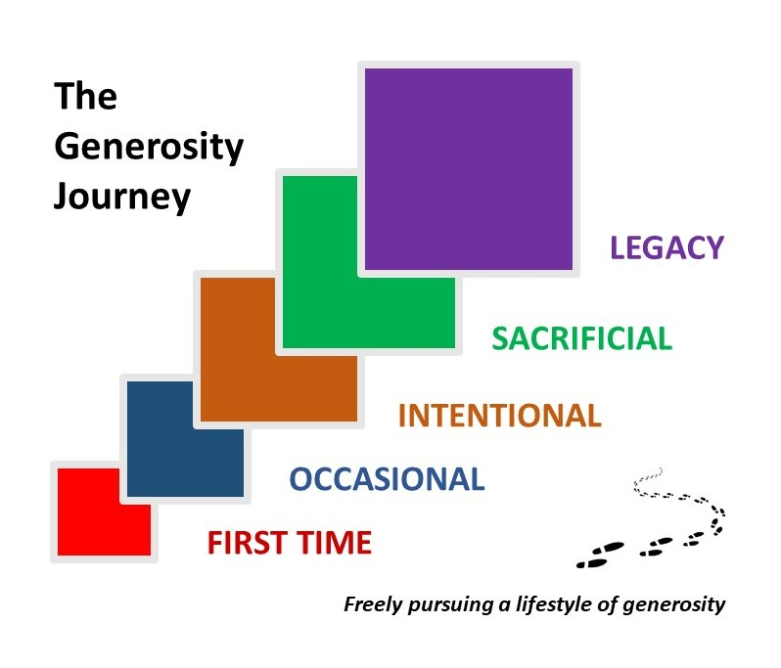

- First Time Giver – Discussion: Notes:
  - If you have never given a financial gift at RHC, whether you are here at the theater or joining us through our livestream, you may consider the participating for your first time.

  - Perhaps you did not know how to give at RHC.
    - If you are newer to RHC, you may have noticed that we do not have a regular “spot” to pass the basket and collect financial gifts.

  - Even before COVID, we decided to remove that experience from our regular routine.
    - For starters, we realized that for some newer Guests, perhaps investigating the claims of Christ, sticking a basket under your nose felt a little coercive and reinforced the misconception that all churches are just after your money.
    - Let me state clearly… a core value when it comes to generosity at RHC is that it should flow freely and joyfully. We regret any donation that is ever offered grudgingly or under compulsion. The only guilt that we encourage is the conviction of the Holy Spirit moving upon the heart of a follower of Jesus Christ. (Cite Scripture)

    - Also, as most people have shifted from checks to digital platforms, we found that the mechanics of collection became increasingly awkward.

- First Time Giver – Next Steps:
  - So… if today, you desire to begin to live a life of maturing generosity flowing through RHC, then your simple next step could be to prayerfully give a First Time gift today.

    - Frankly, you may be concerned that you don’t have enough to give anything. Let me be clear. To get started on your “Generosity Journey”, in my humble opinion, the actual amount isn’t as important as the decision to begin is...

    - In faith, make a decision to simply begin.

  - The RHC App, under “give”, details several ways that you can do it.
    - After the service, you could place an offering inside our secured “Collection Box” just outside the side entrance to this theater.
      - You can write a check or place cash inside an Offering Envelope located there.
    - Use our convenient Mobile Giving Platform accessible through the RHC App.
    - You can even mail a check to RHC PO Box 482 if that is your preference.

- Again, no matter what – simply start by becoming a “First Time Giver”.

- Occasional Giver - Discussion:
  - Once a First Time gift is offered, you are on your way walking towards a life of maturing generosity.

  - For some of you, that may mean responding to generosity opportunities occasionally.
    - Often, it is when you are made aware or specifically asked.

    - Sometimes, a special appeal for a “cause”, like our Turkey Giveaway or Adoption Sunday, is appealing to you and touches your heart.

    - Sometimes, you give when you attend Sunday Worship or when the opportunity is more convenient.

    - And, sometimes you give when you discover that you have “a little extra” in your paycheck that week.

- Occasional Giver - Next Steps:
  - If you have experienced being a First Time Giver, then I encourage you to repeat your first time gift with increasing frequency.

    - Ask the Holy Spirit to strengthen your responsiveness to His promptings and His opportunities.

  - I’ve already outlined the many ways that you can respond so I don’t have to repeat them here.

  - Just know that we really have tried to create as many avenues of giving so inconvenience is not a barrier to your responsiveness.

- Perhaps your next step today is simply to “give again” and then prayerfully seek a more tender heart of generosity.

- Intentional Giver - Discussion:
  - As you grow as an Occasional Giver, you may sense that the Spirit of God is inviting you to be a little less irregular in your approach, a little less reactive in your timing, a little less casual about what He has entrusted to your management.
  - Perhaps, you are beginning to consciously grow towards being an “Intentional Giver” and taking next steps towards living a life of maturing generosity through “commitment”.
  - If so, let me share some biblical characteristics that describe what an “Intentional Giver” looks like:
    - Gives Regularly (in frequency)
      - Could be weekly, or monthly
      - Could be annually (note: grant opportunities shared with me)
      - Could be every time a Commission is earned
      - But there is some predictable pattern to your desire to give

    - Prepares Systematically (in approach)
      - Identifies a clear plan of “How will I give”? Described earlier
        - If married, mutual accountability
        - If single, invite someone else to assist your accountability.
        - If a child, get help from a parent
        - If unsure, talk with a member of our Finance Team

    - Offers “First Fruits” (of what God has already given you)
      - A sense that “First Fruits” belongs to God – returning to Him is a worship priority
      - Avoids sharing “leftovers”

    - Yields Proportionally:
      - Prayerfully determines an Amount or a Percentage of total income available and then commits to giving that amount
      - We recommend percentage
        - Adjusts to income experience (up and down)
        - Note: Sensitive to those experiencing poverty or financial distress
      - Discuss tithe: RHC standard; OT standard (could be up to 33%)

    - Shares through the local Church
      - Committed to build God’s kingdom through the local church
      - Because they believe that the local church is the embodiment of God’s Mission where He has planted that church.
      - Does not mean that charitable giving cannot occur outside the church but…
      - Think of it this way… If you are truly “All In” in joining the mission of God through RHC (Worship attendance, Community in Groups, Serving in Teams, Praying in sync), then why wouldn’t you focus your resources to see that mission and those expressions thrive?
- Intentional Giver - Next Steps:

  - Become more regular in your generosity. Look at your Calendar. Consider how your income flows. Identify your best giving pattern. Aim for consistency.

  - Select your best process for systematically sharing your gifts. Whether it is using an envelope for cash, or mailing a check, or dropping something into the Collection Box each Sunday, or setting up automatic transfers through the RHC App, choose the mechanism that seems wisest for your personal needs.

  - Decide that the first dollars of your income will be to honor God who gave those first dollars to you in the first place. Prioritize your generosity as a lifestyle choice.

  - Review your household budget and identify your giving goals proportionally.
    - On a side note: Some of you have never budgeted, don’t know how to budget, or are struggling with you budget. That is why we offer “Financial Peace University” as an “Equip Class” here at RHC. If you have never taken the opportunity to learn how to plan financially, let us know and we will be happy to help you out.
    - On another side note: Remember that if you choose to donate regularly and systematically through an automated process, revisit your giving periodically to make sure that your desire to be proportional is maintained. In other words, don’t “set it and forget it”. Be an active and attentive giver.

  - Choose to give through the local church (RHC).
    - Simply put, if this is your church home, then express that intention through your giving. Let’s be “all in” – in every way – including financially.

- If you are a First Time Giver or an Occasional Giver, then I strongly encourage you to make progress towards becoming an “Intentional Giver” who shares regularly, systematically, and proportionally even as you offer God’s “First Fruits” as an act of commitment to God’s Mission being accomplished through RHC.

- Sacrificial Giver - Discussion:
  - As you grow as an “Intentional Giver”, a new goal may emerge in your journey. You may discover that even with faithful intentionality, you may be tempted to play it “safe”… to maintain your financial comfort… to make certain that not only “needs” are met but many “wants” are met as well…

  - Certainly, God’s grace gives us freedom to enjoy many of the abundant blessings that He bestows upon us.
  - However, the Scriptures clearly show a Saviour who Sacrifices and Gives Selflessly.
  - And so, a next step in your “Generosity Journey” may be to imitate the example set forth by Jesus and become a “Sacrificial Giver”.

  - A “Sacrificial Giver” is one who gives “above and beyond” what might be expected.
    - A “Sacrificial Giver” is one who evaluates their own comfort and freely offers discomfort as a part of their offering.
    - Instead of asking the question, “What am I giving?”, the “Sacrificial Giver” asks the question “What am I not giving up?”.

    - To become one, giving must “cost” you… it can feel “risky”…
    - And, as you sacrifice, the freedom to deny yourself something with joy… with joy… fuels a greater sense of worship, I believe.

- Sacrificial Giver - Next Steps:
  - Evaluate your personal comfort; then choose a specific way to deny yourself something of value so you can give in sacrifice.
    - This could be a one-time gift or amount… or a special season of giving, like Lent…
    - It could be a new percentage of giving that may produce new discomfort…
    - or it may be adopting a lifestyle that chooses regular sacrifice… or releasing some accumulated possessions, property, or wealth that God might be calling you to yield.

  - You may want to put God to the “test” and do a financial “fast” in order to “feast” on godly generosity.

- If you are an “Intentional Giver”, then I strongly encourage you to make progress towards becoming an “Sacrificial Giver”. For in the Scriptures and throughout the history of Christendom, great joy and profound satisfaction has been the testimony of those who have followed Jesus whole-heartedly and… then chosen to deny themselves some personal comforts in order to give worship through offerings.

- Legacy Giver - Discussion:
  - As you continue your “Generosity Journey”, you may find an increasing conviction that you want to live in such a way that you leave a legacy of lasting impact.
  - You find yourself feeling more and more committed to strategic giving that has Kingdom-Impact flowing from Kingdom-Love.
  - We call this type of person a “Legacy Giver”.

  - Your eagerness to see the mission of God funded by harnessing all of the wealth that is in your care or stewardship causes you to ask, “How much do I really need to keep?”, “How much more can I give?”, and “How can I grow what God has entrusted so I can give even more?”.

  - A “Legacy Giver” often caps their personal spending.
  - Many times, they set a lifetime goal for giving.

  - They weigh all the assets available to them.
  - Then, they evaluate their businesses, their savings, their investments, and their lifestyle so they can maximize their potential to give.

  - They get excited about funding the local church for strategic and long-term impact.
  - Often this extends even beyond their death as they conduct planned giving through their estate. (As it’s been said – “you can’t take it with you”…

- Legacy Giver – Next Steps:
  - In short, if you desire to be a “Legacy Giver”, the most crucial next step that you can take is to understand all the income and wealth that you will ever experience in the light of the “eternity” that lays before each one of us.
  - And, once understood, take one of the steps that I just outlined as characteristics of “Legacy Givers”.

  - In my walk with God, I’ve needed a constant reminder about my life and its trajectory in the light of “eternity”. It is why I have a hand-written Index Card posted on my wall above my desk so I stare at it everytime I sit down to work.
  - It says, “So teach me to number my days that I may get a heart of wisdom” [Ps 90:12]

- For all of us, let’s consider our life of generosity in light of eternity. Certainly, Jesus confronted the “rich, young ruler” in today’s text with eternity. Sadly, the grasp that wealth had upon his heart was too tight and he walked away. My prayer for each follower of Christ within the sound of my voice this morning is that we aspire on-this-side-of-eternity to grasp the potential legacy available through us to the mission of God in our midst.

CONCLUSION – NEXT STEPS (2.5 minutes):

- Wherever you find yourself in your Journey, the Elders and I strongly encourage you to take at least one small next step towards that surrender – freely pursuing a heart of lifestyle generosity.

- In order to help you take a next step in your “Generosity Journey”, you will receive an email me from me later today that will suggest to you a wide range of possible next steps.
  - First, open that email with a prayerful and humble spirit.
    - Spend a moment in prayer, asking the Lord remind you about this morning and where he might be leading you to grow in your generosity and dependence on Him.
  - Second, honestly answer a few simple questions will help you think through this morning’s challenges.
    - Know that your specific answers will only be viewed by me personally, although I’ll share some general conclusions with our Elders and Finance Team so we can learn how to serve you better in this area in the months to come.
  - Third, identify at least one specific next step that you will take as you freely pursue a lifestyle of generosity.
    - I can guarantee you that from the newest Guest here today to the founding members of of RHC, there is an opportunity for each of us to continue our Journeys together.
  - Finally, I hope that you share some of your thoughts with me about your challenges as well as your joys in living out the gospel and relating to our wealth. I am really eager to hear from you.

- Thirty four years after covenanting with each other for life, Teresa and I are still learning and yielding:
  - Our first hesitant gift together as a One-Flesh household became more occasional.
  - As the Spirit of God taught us to become more intentional, we then began to find joy in sacrifice knowing that we could trust Our Provider.
  - Today, we truly desire to leave a legacy that echoes for years to come and bring honor to the name of Jesus.
  - We have not been perfect, far from it… (oh the stories I could tell you if we had more time)
  - But we do encourage you today: “Follow us as we follow Jesus”

- We worship a great and wonderful God – generous of heart; sacrificial in love.
- Let us pray…

INVITATION TO RESPOND & PRAYER (1.0 minutes):

- Heavenly Father…

- In this morning’s reading, we were reminded that what appears in our world to be so terribly complicated can be understood simply - if we yield our hearts to you with the trusting faith of a child.

- In the coming week, we certainly have many questions to discuss with you during our 1,000,000 minutes of Word & Prayer with You.

- But I ask this, Holy Spirit - “Please empower each one of us to answer this most important question personally:

  - “How can I freely pursue a lifestyle of generosity?””

- Lord, help us to proclaim that “glory is due [your] name… whenever we “bring an offering and come into [your] courts”. In Jesus Generous Name. Amen and Amen…

Main Point: Freely pursue a heart of lifestyle generosity (1 of 7 “pursuits” of a disciple – RHC vision)

